
Climate Action Plan
Carleton Rode & Forncett St Peter


1 year plan Spring 2026 – 2027
Nigel.stannett@letsgozero.org

CR’s carbon footprint: 74 tCO₂e (87 in 2024) Calculation: Nov 2025


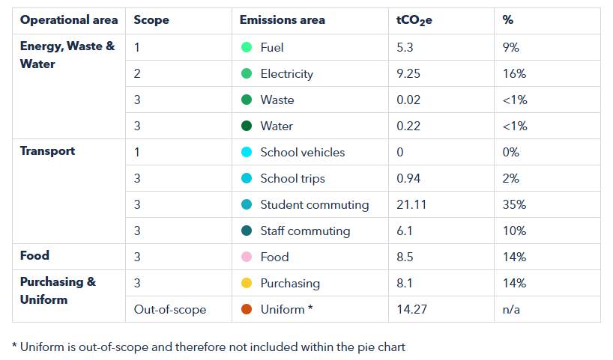

F’s carbon footprint: 74 tCO₂e (87 in 2024) Calculation: Nov 2025

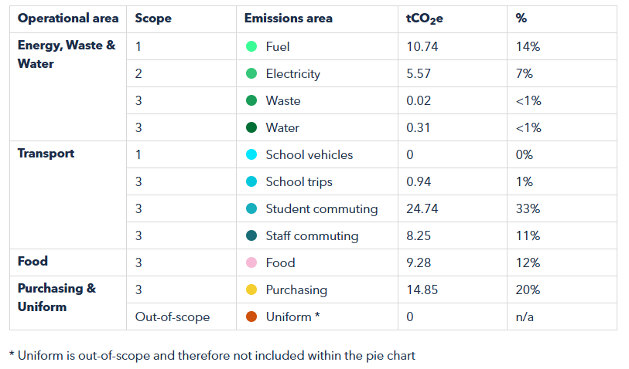

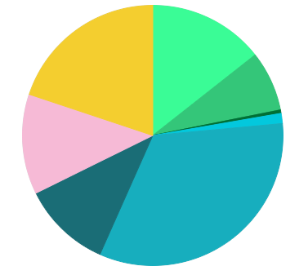

GET STARTED
ACTION | TIMEFRAME | STAKEHOLDERS | NOTES | TRACKER
Calculate your school’s carbon footprint using Count Your Carbon - Fed  This free digital tool allows you to calculate the carbon footprint for your educational setting and gives you a baseline against which to measure progress, year on year. | Start:  Review: |  | Repeat in November 26 | Complete  Nov 25
Add sustainability plans, projects and successes to your school website and share through wider communications - Fed  Celebrate your school’s climate action on your website, in newsletters, social media, local press, and events to showcase your successes and involve the wider community. Use the Let's Go Zero comms pack to do this. | Start:  Review:
Progress Key
Not Started
In Progress
Stalled
Complete
Climate Action Plan history
Last reviewed: | January 2026

= = high carbon reduction actions

1. Decarbonisation and Energy Efficiency
Calculating and taking actions to reduce carbon emissions and becoming more energy efficient
ENERGY – BUILDINGS AND RETROFIT
ACTION | TIMEFRAME | STAKEHOLDERS | NOTES | TRACKER
★ Optimise your BMS/BEMS settings and ensure your heating and hot water systems have efficient timings and temperatures set - Fed  18ºC is the general recommendation for classroom temperatures, whilst hot water coming out of taps should be no higher than 43ºC (stored at 60ºC). Experiment with your heating schedule while maintaining comfort - running it one hour less per day or reducing temperatures by 1 degree can cut annual heating costs by 5–10%, according to the DfE. | Start:  Review: |  | Regular monitoring and adjusting for seasonal weather changes. | Ongoing
★ Insulate your building - Fed  Insulate your cavity walls and/or roof to prevent heat loss, improve energy efficiency and save money. Opt for 'green' insulation where possible, such as wool, aerogel or cotton. | Start:  Review: |  |  | In Progress
Investigate the potential for solar panels - Fed  Find out who you need permission from and contact solar providers to check the suitability of your roof spaces and the financial models available (direct purchase, lease, community energy). Aim to compare approaches from at least three different providers to check you are getting options that work well for your setting. Providers we suggest checking with: Solar for Schools & Eden Sustainable. | Start:  Review: |  | As part of heating system upgrade at CR and as stand alone (though as part of same project) at F. | In progress
Investigate the potential for a ground/air source heat pump - CR  Have a professional assess the suitability of your school site for a ground source or air source heat pump. You may be able to apply for local or national funding for this. Government grants are often published on the SALIX website and via your local Net Zero Hub. | Start:  Review: |  |  | In progress
ENERGY – BEHAVIOURAL CHANGE
ACTION | TIMEFRAME | STAKEHOLDERS | NOTES | TRACKER
Take part in a switch off campaign - Fed  Take part in a switch off campaign, e.g. Switch Off Fortnight. Aim for 10% reduction of energy use (the typical amount saved by participating schools). Running campaigns before the holiday period (such as a summer switch-down) can lead to reduced energy use over the holiday period. | Start:  Review:
Monitor energy use on a regular basis through dedicated platforms - Fed  Use an energy monitoring platform (e.g. Energy Sparks) to visualise and understand your energy usage. Use the data to look for patterns in day-to-day energy consumption and assess your energy baseload (how much energy you use continually). Armed with this information, you can decide where and when is best to target energy savings. If you are already sending your energy data to your provider, get in touch with them and ask them for access. | Start:  Review: |  |  | Ongoing
Implement a power down strategy for energy-intensive appliances over holidays - Fed  Fridges and freezers are often overlooked during holiday and closure periods and require a lot of energy to run. Check every fridge, including the staffroom, and turn them all off over holiday periods. Condense frozen food down to only one freezer to reduce baseload during unoccupied periods and turn any other freezers off. | Start:  Review: |  | Focus on fridges, condense frozen food into fewer freezers?
Access support from your local Net Zero Hub - CR  Regional Net Zero Hubs across England support schools with improving capacity and capability on the journey to reaching net zero. School Business Managers, Operational and Estates staff can access free advice and guidance on a variety of decarbonisation projects, including acquiring Heat Decarbonisation Plans, exploring solar potential and preparing for upcoming governmental grants. | Start:  Review: |  | The Net Zero Hub are able to provide free support for the technical side of installing ASHP/solar etc. They can look at plans, specs when you get to that part.

FOOD
ACTION | TIMEFRAME | STAKEHOLDERS | NOTES | TRACKER
Run a campaign to reduce plate waste from pupils - Fed  Engage pupils in a campaign to cut plate waste. Campaigns might include lessons and assemblies, portion controls, and the option to pre-order, alongside fun activities. WRWA have some ideas to get you started. | Start:  Review: |  | Monitor impact of new caterers.
Introduce or improve on-site composting - Fed  Set up or improve composting for small items like snack-time fruit, as a supplement to your main regular food waste collection. Composting is a great educational tool for engaging students! To get started, ask your school community for unwanted compost bins. | Start:  Review: |  | Need to find alternative support, as Master Composters not available in the local area. | In progress

WASTE
ACTION | TIMEFRAME | STAKEHOLDERS | NOTES | TRACKER
Run waste/plastic reduction initiatives or campaigns with pupils and staff - Fed  Take school-wide action to reduce waste. Run an initiative yourself, or engage with a local or national campaign. For example, you could work to become a Plastic Free School with Surfers Against Sewage using their free resources. | Start:  Review: |  | Running Plastic Free Schools programme at both schools. | In progress
Take part in additional recycling schemes - Fed  Take part in additional recycling schemes for items that cannot be recycled in regular waste collections. Some schemes can even generate income or green points. For example; Empties Please (ink cartridges); Recycle to Read:(toys, batteries and textiles); Bag2School and Little Recyclers (textiles); Eddings (pens). | Start:  Review: |  | Already have battery recycling. | In progress

PROCUREMENT
ACTION | TIMEFRAME | STAKEHOLDERS | NOTES | TRACKER
★ Follow sustainable practices when choosing external companies and how you use them - Fed  This involves researching and understanding the sustainability and ethical credentials of companies before buying from them, e.g. ensuring they do not take part in deforestation practices. Incorporating sustainable buying practices, e.g. buying in bulk, can also improve the sustainability of your procurement. | Start:  Review: |  | Guidance from Diocese?

TRANSPORT
ACTION | TIMEFRAME | STAKEHOLDERS | NOTES | TRACKER
Develop an active travel plan – both schools.  Create and implement your school travel plan which supports cycling, walking and other forms of sustainable travel. NCC AtoB programme, Travel Norfolk for Schools Modeshift Stars Education. | Start:  Review:

2. Climate adaptation and resilience
Taking actions to reduce the risk of flooding and overheating and to future-proof scarce resources for potential shortages

ADAPTATION AND RESILIENCE
ACTION | TIMEFRAME | STAKEHOLDERS | NOTES | TRACKER
Monitor overheating in classrooms and install measures that prevent overheating  Assess the need for solar shading on south/west/east-facing classrooms. Look at the most effective measures based on the amount of sunlight, e.g. External blinds/awnings. Solar film can be used but may cause heat retention as well and limit light into classrooms. | Start:  Review:

WATER
ACTION | TIMEFRAME | STAKEHOLDERS | NOTES | TRACKER
Raise awareness around water consumption and efficiency - Fed  Consider engaging with your local water company who may have an education team or free resources on their websites, from assembly sessions and visits to primary schools for your pupils to webinars, downloadable tools and guides, and more. Anglian Water resources | Start:  Review:
3. Biodiversity and Green Infrastructure
Creating habitats and adopting practices that will enhance species diversity on the school estate and beyond

NATURE
ACTION | TIMEFRAME | STAKEHOLDERS | NOTES | TRACKER
Take part in The Nature Park - Fed  The Nature Park aims to embed nature-based learning into the curriculum and encourage children and young people all over the country to take action to improve their site for people and wildlife. The programme provides the support and guidance needed to make this happen, with five key steps in the journey and the actions needed to reach your goals. | Start:  Review: |  | Have mapped boundary – map habitats next. | In progress
Increase biodiversity to support local wildlife e.g. add a pond, plant pollinator-friendly plants, put up birdfeeders, bat boxes and 'bug hotels' - Fed  Develop your outdoor spaces to create a mosaic of habitats and features to provide food, shelter and water for wildlife. Grant funding is often available for this, and make use of the wider community for support and resources. | Start:  Review: |  | Ask local community for support and materials.
Increase planting of available areas - Fed  Identify areas in your school grounds which could accommodate new planting. This could include hedgerows, trees and wildflower meadows or native plants in borders, planters or pots. When planning ensure the "right tree in the right place" principle is followed and consider accessibility and maintenance requirements. | Start:  Review:

4. Climate Education, Green Skills and Green Careers
Ensuring the education you provide gives knowledge-rich and comprehensive teaching about climate change, and that your teaching staff feel supported to offer this

CULTURE
ACTION | TIMEFRAME | STAKEHOLDERS | NOTES | TRACKER
Appoint a sustainability focused governor  Appoint a link governor who will work directly with the Sustainability Lead to deliver the Climate Action Plan. | Start:  Review:
Set up an Eco Club or Eco Council for pupils to lead on sustainability initiatives - F  Establish a student Eco-Club/Council. Consider inclusivity and longevity of projects so that as many students as possible can take part throughout their time at school. | Start:  Review: |  |  | In progress
Provide CPD opportunities for staff on sustainability - Fed  Investigate appropriate CPD opportunities for staff, e.g. sharing existing sustainability related content and developing skills through Carbon Literacy Training , Climate Fresk or our own Let's Go Zero session that can be delivered in person at staff INSET or remotely. Teaching for sustainable futures | UCL Institute of Education. | Start:  Review: |  |  | In progress
Support your staff to attend local sustainability networks & events - Fed  Include sustainability networks and events in your staff CPD offer and encourage and support staff to attend. You can include the Let's Go Zero webinar schedule in your CPD offer plus events from UKSSN, National Education Nature Park and other offers local to your school. | Start:  Review: |  |  | In progress
Engage with staff on sustainability to support CAP actions. | Start:  Review: |  |  | Ongoing

CURRICULUM
ACTION | TIMEFRAME | STAKEHOLDERS | NOTES | TRACKER
Review current sustainability offer in the curriculum and monitor impact. - Fed  Amend your curriculum to include stronger links to climate change and sustainability. This could be a total refresh, a bit of tweaking, drop down days or simply adding extra assemblies. Teach the Future, Royal Meteorological Society (Curriculum for Climate Literacy) and the MoEE have amazing resources on how to weave sustainability throughout your curriculum. | Start:  Review: |  |  | In progress
Create an environment where lessons can be taught outside in all subjects - Fed  Improve outdoor learning and encourage creative pedagogy that enables students to connect with nature and the local community. Set up regular opportunities to learn in nature across all areas of the curriculum. You can get support and advice from the Forest School Association, Learning Through Landscapes or the National Education Nature Park. | Start:  Review: |  | Linked to Nature Park work.

GREEN SKILLS & CAREERS
ACTION | TIMEFRAME | STAKEHOLDERS | NOTES | TRACKER
Continue to access the Climate Ambassadors scheme - Fed  Connect with Climate Ambassadors in your region and invite them to do school assemblies on green skills and curriculum linked topics. | Start:  Review:
Invite inspirational green careers speakers in to speak to pupils - Fed  Find green careers speakers to inspire pupils. This could include parents or governors. Use Primary Futures, Inspiring the Future, Speakers for Schools to find speakers. | Start:  Review: |  | Linked with Climate Ambassadors programme. | In progress

Possible Year 3 actions

Develop a Sustainable Procurement policy - Fed  A Sustainable Procurement Policy is a document that outlines your school or MAT's commitment to purchasing in a way that is both sustainable and ethical. You can find some further advice and links on creating a sustainable procurement policy here. | Start:  Review:




www.letsgozero.org

Ashden is registered in England and Wales as a company limited by guarantee.
Registered number: 05062574/ Charity number: 1104153
The Peak, 3rd Floor 5 Wilton Road, London, SW1V 1AP

